Problem Statement 2: Array Index Out of Bounds Exception
You are given a program skeleton that involves an array and a method accessing an element. Your
task is to complete the program by adding the necessary exception-handling code to catch and
handle the ArrayIndexOutOfBoundsException that may occur if an invalid index is accessed.

Coding:
public class ArrayIndexExample {
public static void main(String[] args) {
int[] numbers = {1, 2, 3, 4, 5};
try {
int result = accessArrayElement(numbers, 10);
System.out.println("Result: " + result);
} catch (ArrayIndexOutOfBoundsException e) {
System.out.println("ArrayIndexOutOfBoundsException caught: " + e.getMessage());
}
private static int accessArrayElement(int[] array, int index) {
if (index < 0 | | index >= array.length) {
throw new ArrayIndexOutOfBoundsException("Invalid array index");
}
return array[index];
}

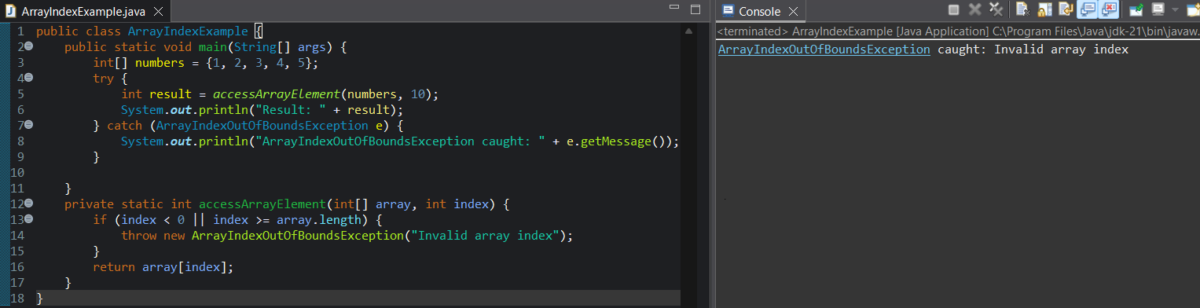

Corrected Code:
public class ArrayIndexExample {
public static void main(String[] args) {
int[] numbers = {1, 2, 3, 4, 5};
try {
int result = accessArrayElement(numbers, 10);
System.out.println("Result: " + result);
} catch (ArrayIndexOutOfBoundsException e) {
System.out.println("ArrayIndexOutOfBoundsException caught: " + e.getMessage());
}

}
private static int accessArrayElement(int[] array, int index) {
if (index < 0 || index >= array.length) {
throw new ArrayIndexOutOfBoundsException("Invalid array index");
}
return array[index];
}
}

